Year 12 Mathematical Methods

**Task 7 (10%):** Test 4 Non Calc – CRVs, Normal Distribution, Sampling and Confidence Intervals

(4.2.1 – 4.2.7, 4.3.1 – 4.3.10)

|  |
| --- |
| INSTRUCTIONS:  **Non Calculator**; Notes not allowed; Full working must be shown for all questions (or parts) worth more than 2 marks; Marks will be deducted for rounding, unit or notation errors; Formula Sheet allowed |
| Name: Time:25 minutes Total_____ / 25   |  |  |  |  | | --- | --- | --- | --- | | -1 | Rounding | Units | Notation | |

**Question 1 (5 marks)**

Ian finds it hard to get to school in a morning. He recorded how late he was for Maths on a Monday morning for 38 lessons. The histogram below shows the distribution of his arrival times, with *t* representing the number of minutes after the second bell.

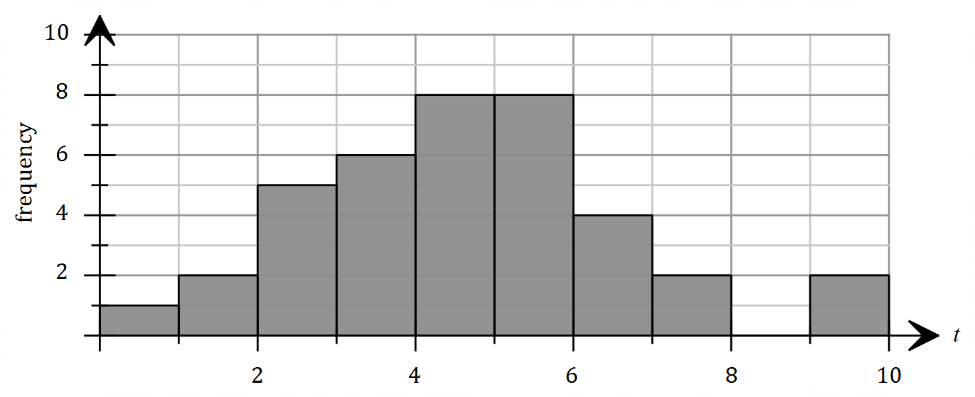

Find an estimate of the probability that Ian arrives to the next Monday morning lesson:

1. More than 6 minutes late. [1]
2. Less than 7 minutes late, given he is more than 4 minutes late. [2]

The notices are read out at the same time every morning.

1. There is a 50% chance of Ian arriving during the notices being read out. How many minutes after the bell must the notices start and finish? [2]

**Question 2 (9 marks)**

The continuous random variable X has the probability density function graphed below.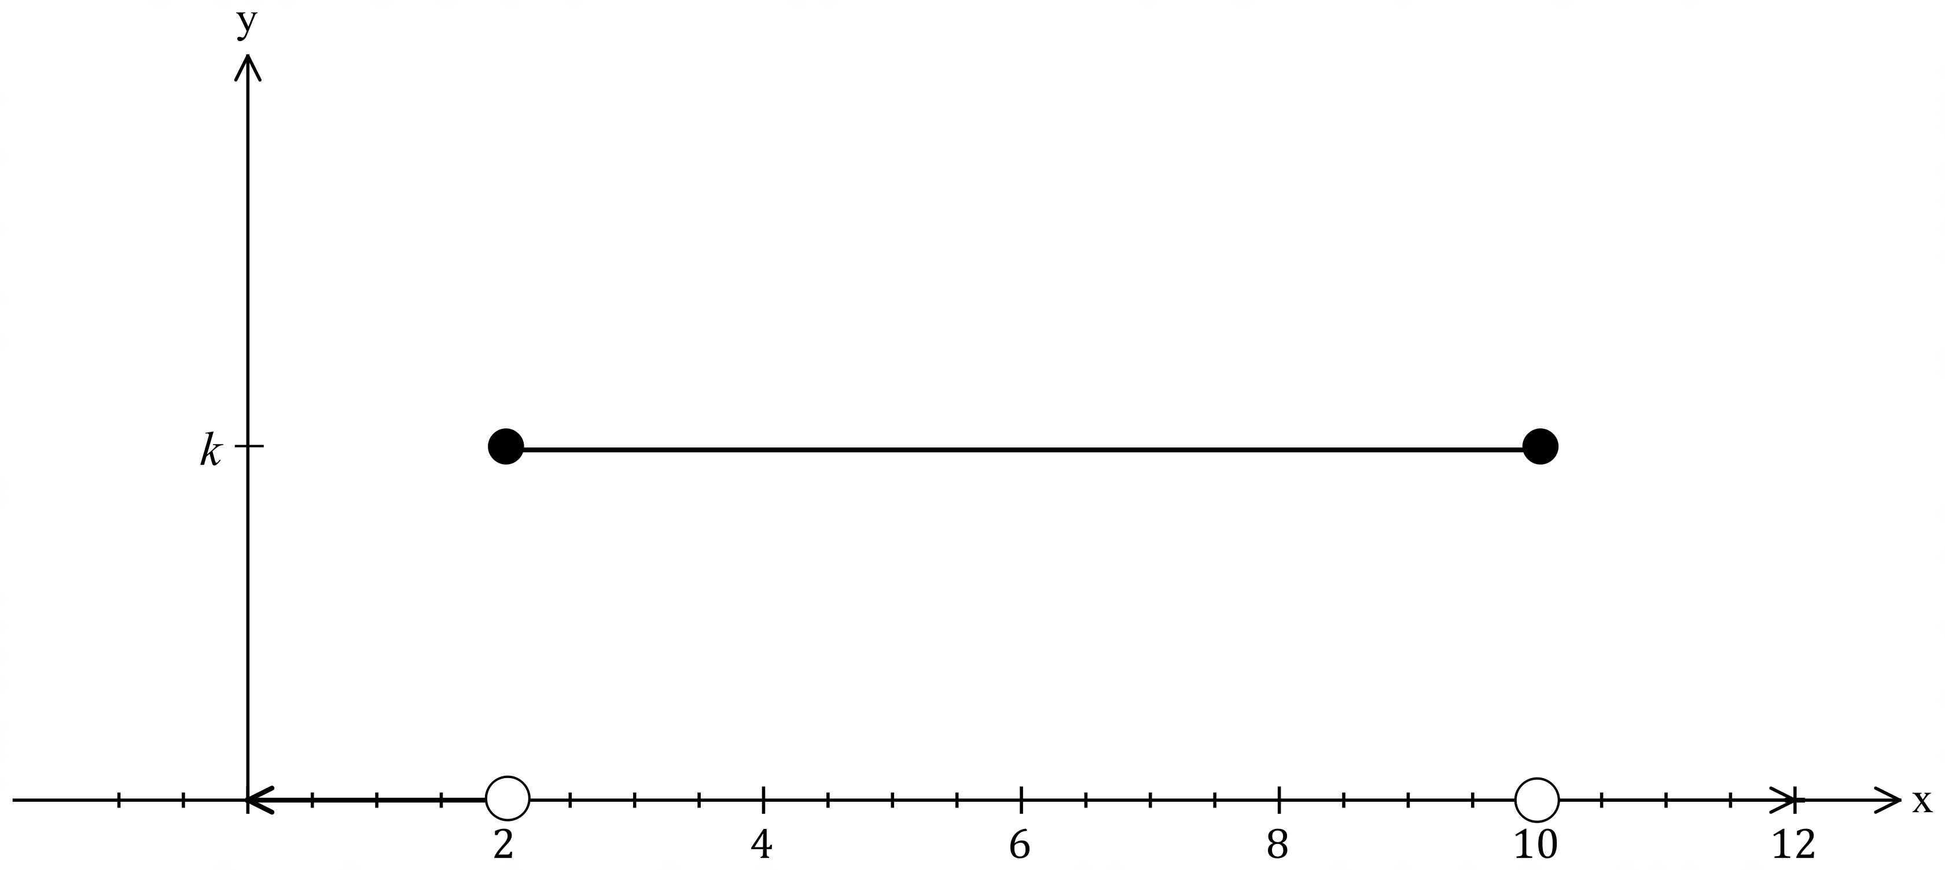

1. Find *k*. [1]
2. Find P(2 < X < 5) [1]
3. Find P(X < 8 | X > 4) [2]
4. Find the expected value of X [2]
5. Find the variance of X [3]

**Question 3 (7 marks)**

Joel has a banana tree in his garden. The mean weight of bananas grown on Joel’s tree is 150g and they have a standard deviation of 18g. Banana weight is known to be normally distributed.

1. What percentage of bananas grown on Joel’s tree would be over 186g? [1]
2. What is the probability that a randomly selected banana would weigh between 114g and 168g? [2]
3. Everyone knows that small bananas are the tastiest. A small banana is any banana weighing less than 132g. One summer Joel’s tree produced 200 bananas. How many delicious small bananas did it produce? [2]
4. 5 of the 200 bananas weighed less than *x*g. Find an estimate for the value of *x* [2]

**Question 4 (4 marks)**

The time between Tommy making a mistake on a maths question and Jake making a joke about the mistake can range from 2 to 7 seconds and the times are uniformly distributed.

1. What is the probability that Jake waits for less than 6 seconds before making a joke? [2]
2. Amelia notices that 40% of the time more than *t* seconds passes before the joke is made.

Find the value of *t*. [2]

END of NON-CALC SECTION

Year 12 Mathematical Methods

**Task 7 (10%):** Test 4 Non Calc – CRVs, Normal Distribution, Sampling and Confidence Intervals

(4.2.1 – 4.2.7, 4.3.1 – 4.3.10)

3.2.14,3.2.19,3.2.21)

|  |
| --- |
| INSTRUCTIONS:  **Calculators permitted (Scientific or CAS)**; Notes not allowed; Full working must be shown for all questions (or parts) worth more than 2 marks; Marks will be deducted for rounding and unit errors;  Formula Sheet allowed |
| Name: Time: 30 minutes Total_____ / 32   |  |  |  |  | | --- | --- | --- | --- | | -1 | Rounding | Units | Notation | |

**Question 5 (9 marks)**

An organic grocery store sells quinoa in bags labelled as containing 1kg. In reality though, the weight of quinoa in the bags is normally distributed with a mean of 1012g and a variance of 72g.

1. What is the probability of randomly selecting a bag of quinoa that is below the advertised weight? [2]
2. What two weights do the middle 25% of bag weights fall between? [2]
3. The grocery store decides to try and reduce the percentage of underweight bags to be no more than 1%. What should they increase the mean weight of bags to, assuming the standard deviation doesn’t change? [2]

The store also sells macadamias. It is known that 5% of macadamias have a weight below 11g and 13% have a weight above 20g.

1. Find the mean and standard deviation of the macadamias. [3]

**Question 6 (16 marks)**

The probability density function for a continuous random variable, *X*, is given by the function:

$$f\left(x\right)=\left\{\begin{aligned}2\left(x-1\right) for 1≤x≤2 \\ 0 otherwise\end{aligned}\right.$$

1. 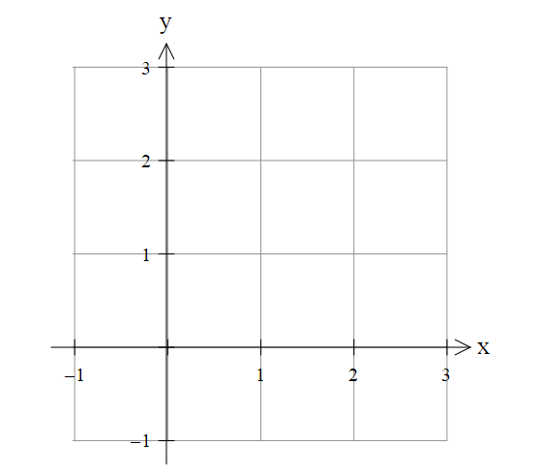Sketch the graph of the probability density function *f(x)*  [2]
2. Find P(*X* ≤ 1.5) [2]
3. Find P(*X ≥* 1.1 │ *X* ≤ 1.5) [2]
4. Find the expected value of the distribution [2]
5. Find the variance of the distribution [2]
6. Random variable Y is formed from X according to the relationship *Y* = 4*X* + 10
   1. Find the mean of *Y* [1]
7. Find the Variance of *Y* [1]
8. State the Cumulative Distribution Function of *X* [2]
9. Find an exact value for the median, m, of *X* [2]

**Question 7 (2 marks)**

Bruno Fernandes’ scoring statistics for Manchester United for the last two seasons are below:

|  |  |  |  |
| --- | --- | --- | --- |
| Season | Fernandes’ goals per game | Mean goals per game for all players | Standard Deviation |
| 2022/23 | 0.37 | 0.17 | 0.11 |
| 2023/24 | 0.22 | 0.13 | 0.09 |

Use standard scores to demonstrate which season he performed better in.

**Question 8 (5 marks)**

Arun owns a sink manufacturing company. He surveyed a random selection of 200 people to find out if they had purchased a sink or tapware in the last 6 months. 22 of those surveyed said they had.

1. Determine the sample proportion $\hat{p}$, of people who purchased a sink or tapware in the last 6 months [1]
2. Estimate the mean and standard deviation of the random variable $\hat{p}$, for such samples of size 200.

[2]

1. The population proportion of people who have purchased a sink or tapware in the last 6 months is actually 12.5%. If Arun does a second survey, this time of 90 people, what is the probability that fewer than 10 people answer yes? [2]

END of CALC SECTION